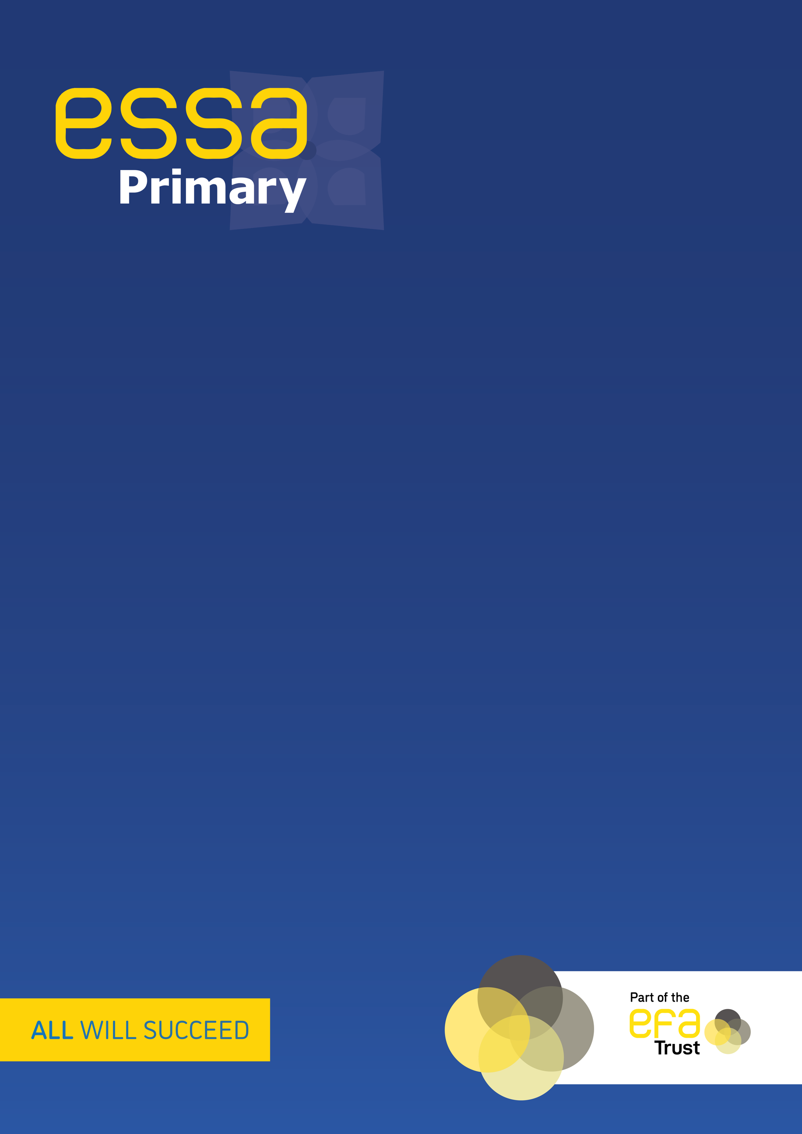
Punctuation progression in Knowledge and Skills
EYFS – Y6
2023-2024
Punctuation knowledge and skills | Reception
 | Identify | Understand | Use | Apply
 | I can identify what a capital letter looks like | I know why we need a capital letter at the beginning of a sentence | I can use a capital letter at the beginning of a sentence | I can independently use capital letters when writing sentences
 | I can identify what a capital letter looks like | I know why we need a capital letter for our names | I can use a capital letter for my name | I can independently use capital letters when writing sentences
 | I can identify what a capital letter looks like | I know why we need a capital letter for ‘I’ | I can use a capital letter for ‘I’ | I can independently use capital letters when writing sentences
 | I can identify a full stop and where it is placed | I know why and when we use a full stop | I can use a full stop at the end of a sentence | I can independently use a full stop when writing sentences
 | Year 1
 | Identify | Understand | Use | Apply
 | I can identify a capital letter in different contexts | I know why a capital letter is used for the beginning of a sentence and the pronoun ‘I’ | I can use a capital letter at the beginning of a sentence and for the pronoun ‘I’ | I can independently punctuate sentences with capital letters
 | I can identify a capital letter in different contexts | I know why a capital letter is used for names of people, places and days of the week | I can use a capital letter for names | I can independently recognise and choose when a capital letter is needed
 | I can identify a full stop and where it is placed | I know why we use a full stop at the end of a sentence | I can end sentences with a full stop and use full stops correctly in more than one sentence | I can independently punctuate sentences and short paragraphs with
 | I can identify a question mark  I can identify question words that start sentences | I know why a question mark is used at the end of a sentence | I can write questions beginning with who, what, where, when, why and how  I can use a question mark correctly at the end of a sentence | I can independently write correctly punctuated questions and answers
 | I can identify an exclamation mark  I can identify words that start an exclamation sentence | I know that an exclamation mark is used to show surprise  I know that an exclamation mark ends an exclamation sentence | I can write correctly punctuated exclamation sentences  I can use exclamations to show surprise | I can independently use exclamation marks
 | Year 2
 | Identify | Understand | Use | Apply
 | I can identify a comma and where it is placed | I know the function of commas in lists | I can add commas to a list  I can write lists containing commas in the correct place | I can independently use commas in lists
 | I can identify an apostrophe and where it is placed  I can identify words that can be contracted using an apostrophe | I know how to make a contraction using an apostrophe | I can write sentences containing contracted words  I can turn two words into a contraction  I can turn a contraction into two separate words | I can independently write sentences containing contractions with correctly placed apostrophes
 | I can identify an apostrophe and where it is placed  I can identify a singular noun | I know why we use an apostrophe to show something belongs to someone | I can add apostrophes in the correct place to show possession | I can independently use apostrophes for singular possession in nouns  I can write sentences containing correctly punctuated possessive nouns
 | Year 3
 | Identify | Understand | Use | Apply
 | I can identify a comma and where it is placed  I can identify common adverbials | I know why a comma is needed after a fronted adverbial | I can add a comma after a fronted adverbial | I can independently write sentences using correctly punctuated fronted adverbials
 | I can identify an apostrophe and where it is placed  I can identify a plural noun | I know why an apostrophe is used to show possession  I can explain the difference between singular and plural possession | I can add an apostrophe in the correct place in a plural noun to show possession | I can independently use a correctly placed apostrophe for the possessive plural
 | I can identify pairs and single inverted commas, including where they are placed  I know what a reporting clause is | I understand that inverted commas go around the words being spoken  I understand that inverted commas need punctuation to separate them from the reporting clause | I can write dialogue with inverted commas in the correct place  I can correctly position punctuation to separate dialogue from the reporting clause | I can use inverted commas and other necessary punctuation to punctuate direct speech correctly.
 | Year 4
 | Identify | Understand | Use | Apply
 | I can identify a comma and where it is placed  I can identify main and subordinate clauses | I know why a comma is needed to separate a main clause from a subordinate clause  I know that a comma should not be used to separate 2 main clauses | I can add commas to sentences to mark clauses  I can write sentences where commas mark clauses | I can independently write sentences using commas to mark the boundary between clauses, using a main and a subordinate clause
 | I can identify an apostrophe and where it is placed  I can identify singular and plural nouns  I can identify irregular plural nouns  I can identify the different uses of apostrophes | I understand the difference between singular and plural nouns  I understand that irregular plural nouns do not follow the same rules as regular plurals  I understand that apostrophes are used for both contraction and possession | I can add apostrophes correctly to all types of nouns to show possession  I can add apostrophes to all contractions | I can independently use apostrophe’s for contraction and possession
 | I can identify pairs and single inverted commas, including where they are placed  I can identify a reporting clause at the beginning or end | I understand that inverted commas go around the words being spoken  I understand that inverted commas need punctuation to separate them from the reporting clause | I can write dialogue with inverted commas in the correct place  I can correctly position punctuation to separate dialogue from the reporting clause at the beginning or end | I can use inverted commas and other necessary punctuation to punctuate direct speech correctly.
 | I can identify an ellipsis and where it is placed on the line | I understand that an ellipsis can be used to show passing of time, to create tension or to show a pause  I can identify why an ellipsis has been used in a sentence | I can write sentences containing an ellipsis  I can add an ellipsis to a sentence | I can use an ellipsis for a variety of purposes and explain why I have used it
 | Year 5
 | Identify | Understand | Use | Apply
 | I can identify commas, where they are placed and in which direction they go  I can identify a phrase, a main clause and a subordinate clause | I understand and can explain the different purposes commas are used for  I understand that sentences can mean different things depending on where a comma is placed | I can add commas in lists  I can add commas to separate main and subordinate clauses, and to separate phrases  I can move the position of a comma in a sentence and explain the impact | I independently use commas accurately and consistently for a variety of purposes (lists, phrases, clauses and for clarity)
 | I can identify commas and where they are placed  I can identify pairs of brackets  I can identify a dash  I can identify parenthesis in a sentence | I understand that additional information needs to be placed inside brackets, commas or dashes  I understand the impact of not using punctuation | I can insert brackets, commas and dashes to indicate parenthesis | I can independently use a pair of commas, brackets or dashes to indicate parenthesis when writing a sentence  I can choose the correct punctuation to use depending on the level of formality
 | I can identify bullet points in a text | I know why bullet points are used  I know that bullet point punctuation must be consistent (commas after every point and a full stop or no punctuation) | I can add punctuation correctly to a set of bullet points  I can write a list as bullet points, punctuation it correctly | I can punctuate bullet points consistently, independently choosing which punctuation to use
 | I can identify a semi-colon and where it is placed on the line  I can identify main clauses | I understand why a semi-colon rather than a comma is used to separate main clauses  I understand that a semi-colon can be used in place of a full stop or a conjunction | I can add a semi-colon in the correct place in a sentence  I can write a main clause after a semi colon | I can independently use semi-colons to mark the boundary between main clauses
 | Year 6
 | Identify | Understand | Use | Apply
 | I can identify a hyphen  I can differentiate between a hyphen and a dash | I understand why a hyphen is needed in a compound noun  I understand that sentences can mean different things depending on whether a hyphen is used | I can add hyphens to compound nouns  I can change the meaning of a sentence using a hyphen | I can independently choose to use hyphens in compound adjectives and to avoid ambiguity
 | I can identify a colon and where it is placed on the line | I know that colons can be used for different purposes  I know that a colon can introduce a list of items  I know why a colon might be used between two main clauses | I can correctly use a colon to introduce a list  I can correctly add a colon to separate two main clauses  I can write a main clause after a colon | I can independently choose when to use a colon to introduce a list or mark the boundary between main clauses
 | I can identify a semi-colon  I can identify an expanded noun phrase | I understand the difference between using a comma and a semi-colon in a list | I can decide if a comma or semi-colon is needed to separate items in a list  I can add semi-colons to a list of items | I can independently use semi-colons to separate items in a list
 | I can identify a dash and where it is placed  I can differentiate between a dash and a hyphen | I know when a dash might be used to mark the boundary between clauses  I can explain why a dash rather than a colon/semi-colon is used | I can add a dash to a sentence  I can write a clause after a dash | I can independently mark the boundary between clauses using a dash.  I can independently choose to use a dash to reflect formality of writin

