Week 4 | Dish of the Day | Dish of the Day 2 | Vegetables  Or Salad | Potato  or Rice | Dessert
Monday | Chicken samosa with Noodles & Curry sauce 1,2,7,9,10,13 | Cheese & Tomato Macaroni  1,2,6,7 |  | Garlic bread  2,6 | Homemade Biscuit or Cake or fruit
Tuesday | Tuna Pasta Bake  2,4,5,7 | Quorn Chili Flatbread  1,2,6,12 | Beans  Salad |  | Homemade Biscuit or Cake or fruit
Wednesday | 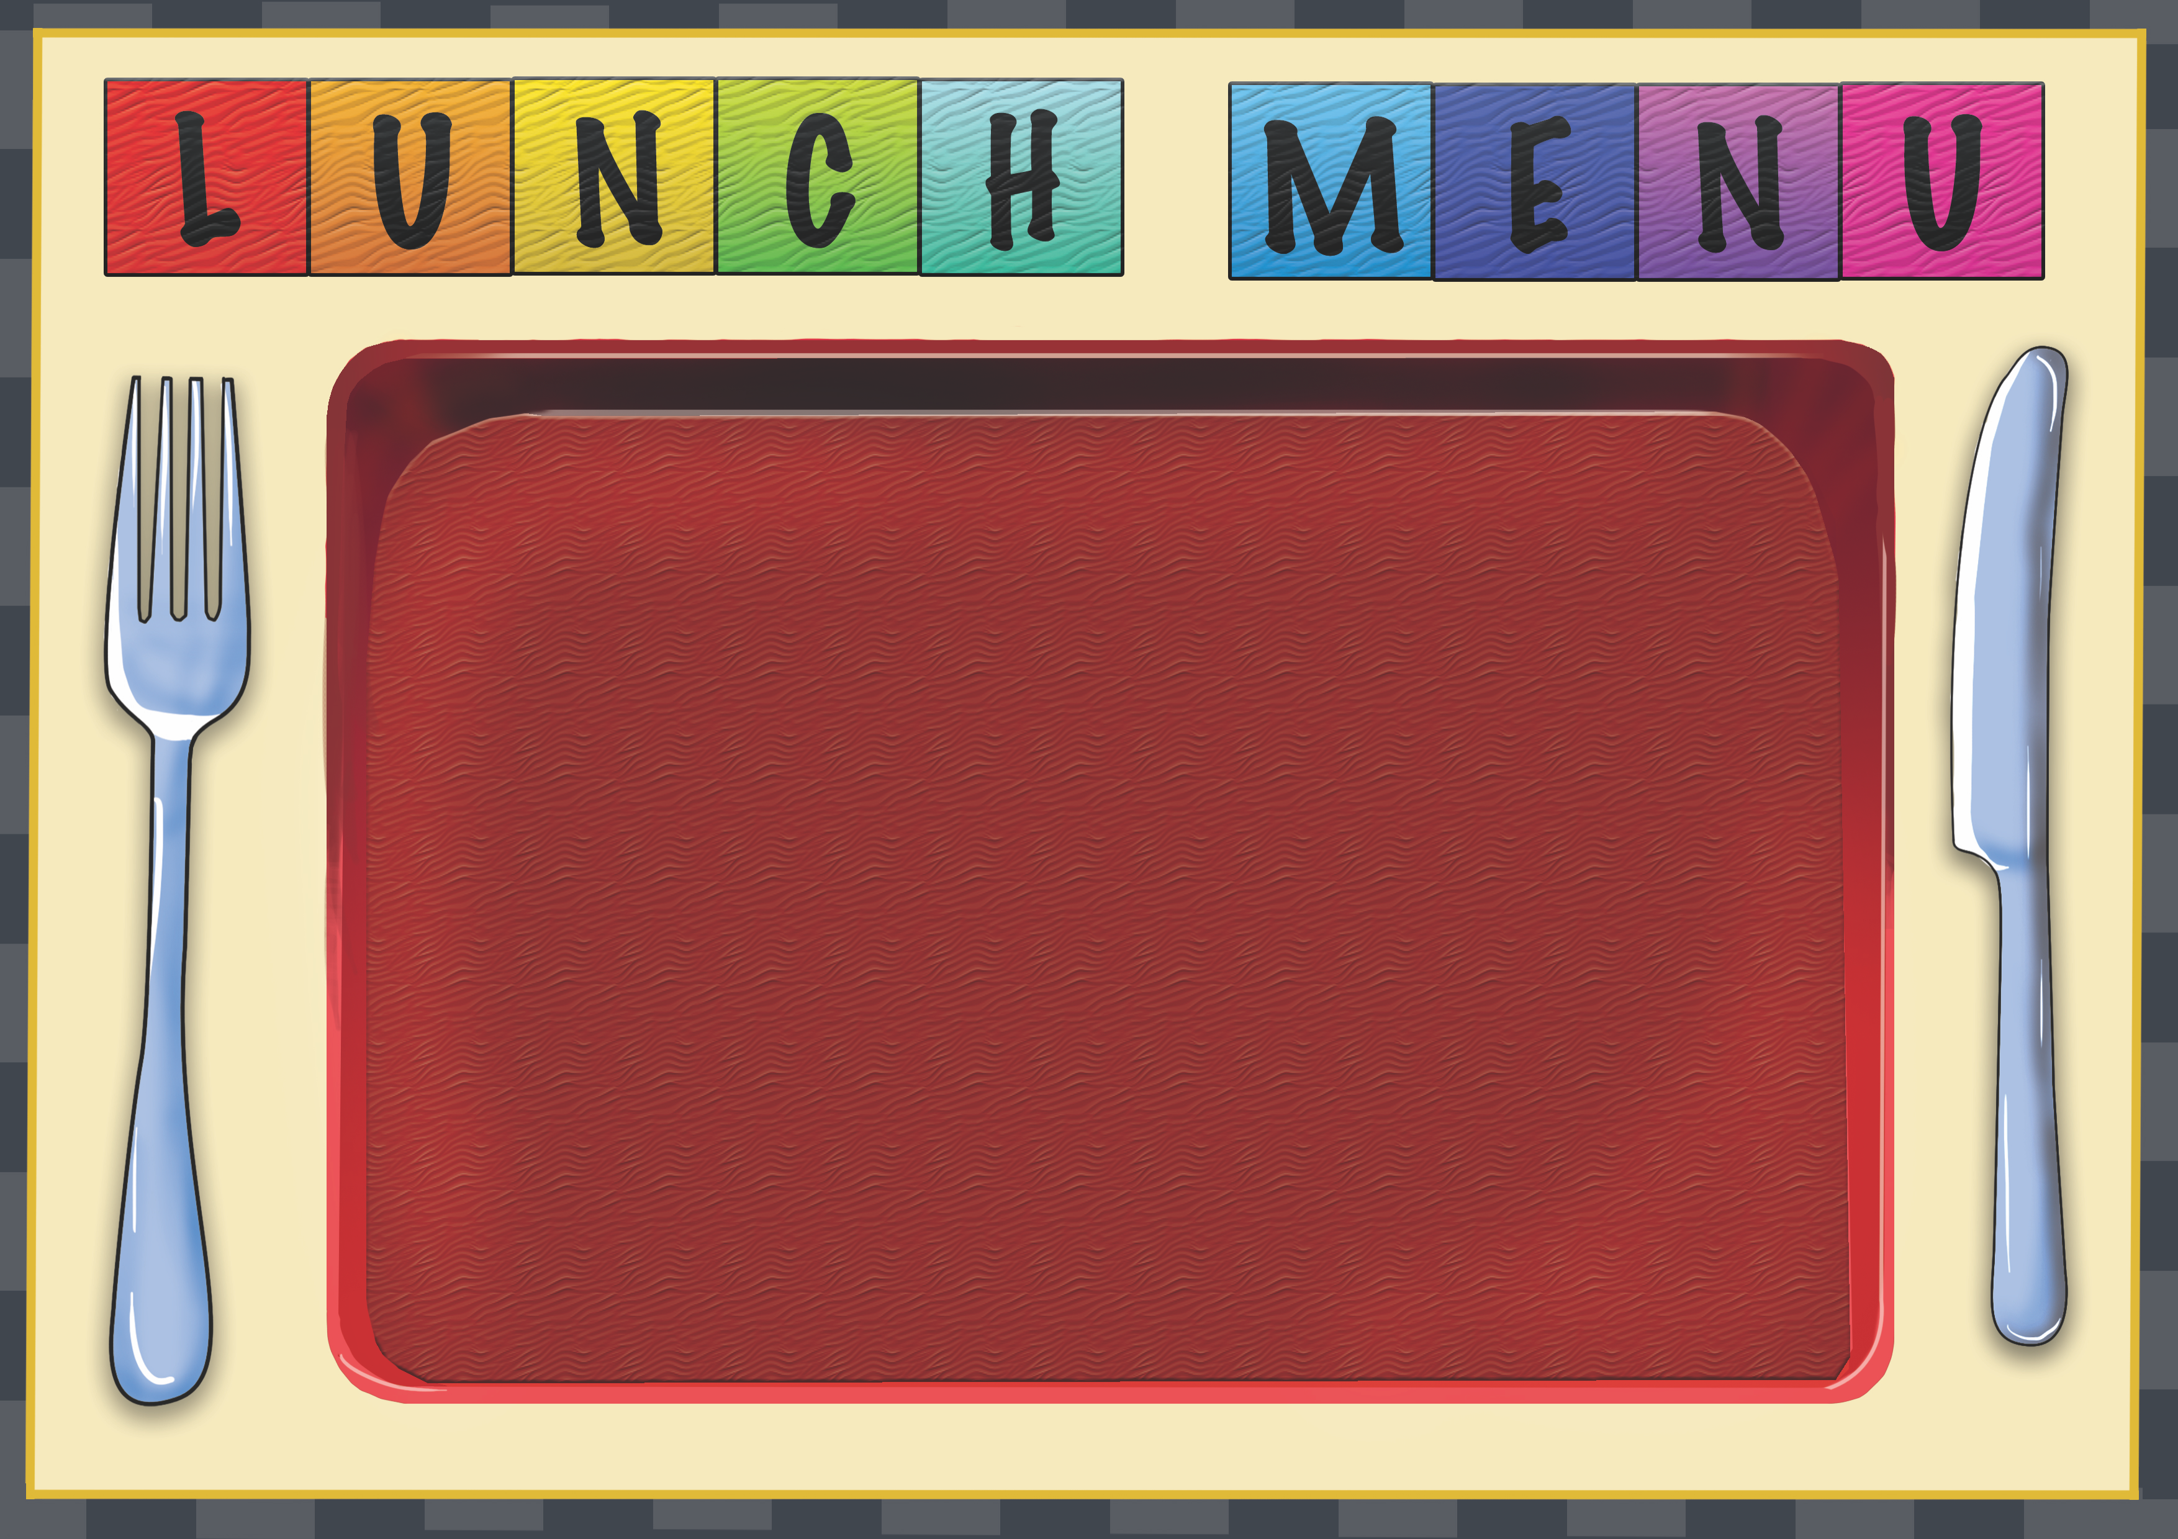  Meat & Potato Pie  1,2,4, | Quorn Pasta Bolognaise  1,2,6,13 | Beans | Garlic Bread  2,6 | Homemade Biscuit or Cake or fruit
Thursday | Beef Lasagna  1,2,6,7, | Cheese & Tomato Panini  2,4,7 | Sweet corn | Diced Herb | Homemade Biscuit or Cake or fruit
Friday | Jacket Potato with a choice of fillings  4,5,7 | Beef Sausage roll  2,4,6 | Salad  Baked Beans |  | Homemade Biscuit or cake or fruit

