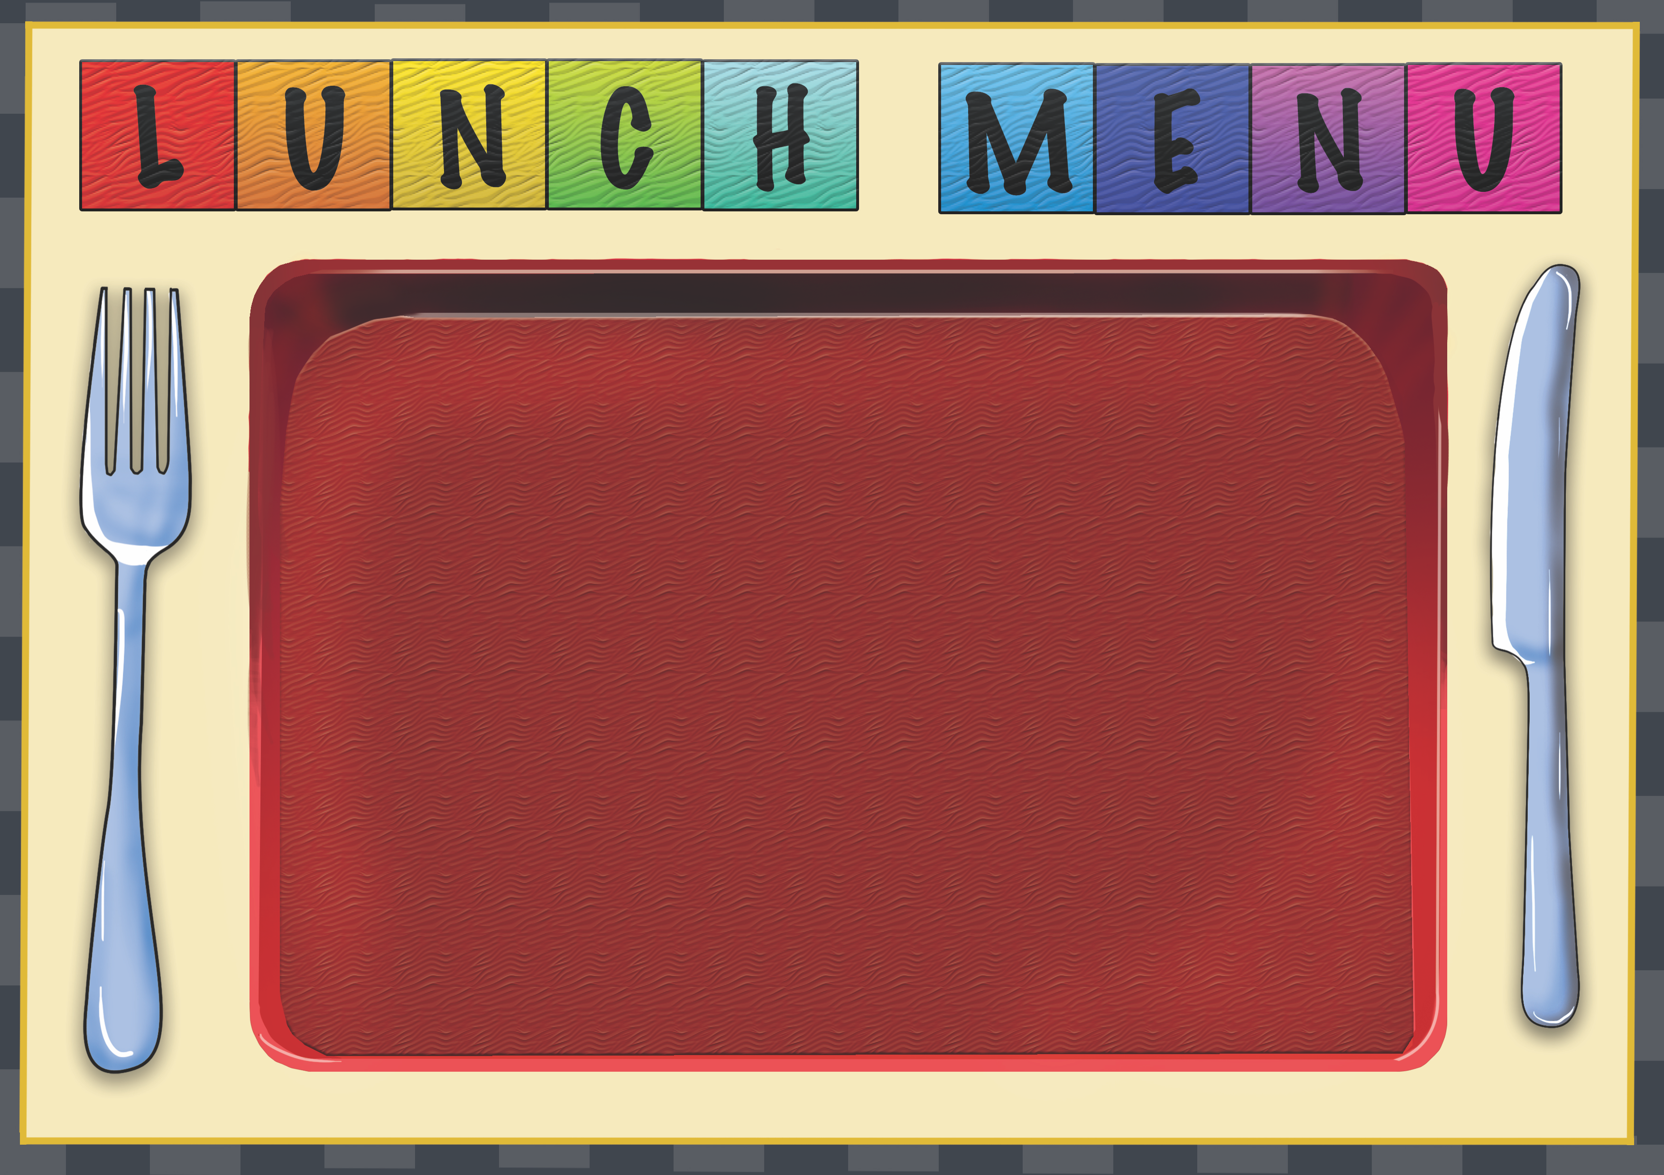
Week 3 | Dish of the Day | Dish of the Day 2 | Vegetables  Or Salad | Potato  or Rice | Dessert
Monday | Vegetable Spring roll  2,7,9,10,13 | Chicken Tikka Masala with Noodles  1,2,6,7,9 | Salad  Sweetcorn |  | Homemade Biscuit or Cake or fruit
Tuesday | Cheese & Tomato Panini  2,4,7 | Fishcake  1,2,4,5,7 | Baked Beans  Or  Salad | Diced Potato | Homemade Biscuit or Cake or fruit
Wednesday | Roast Chicken  1 | Quorn Sausage Flatbread  2,6,7 | Salad  Mixed Veg | Mashed Potato | Homemade Biscuit or Cake or fruit
Thursday | Pizza slice  2,7 | Cheese & Onion Pie  2,4,7 | Beans  Or  Sweetorn | Herb New | Homemade Biscuit or Cake or fruit
Friday | Battered Cod  2,5,6,7 | Jacket Potato with a choice of fillings 4,5,7 | Salad  peas | Chips | Homemade Biscuit or Cake or fruit

