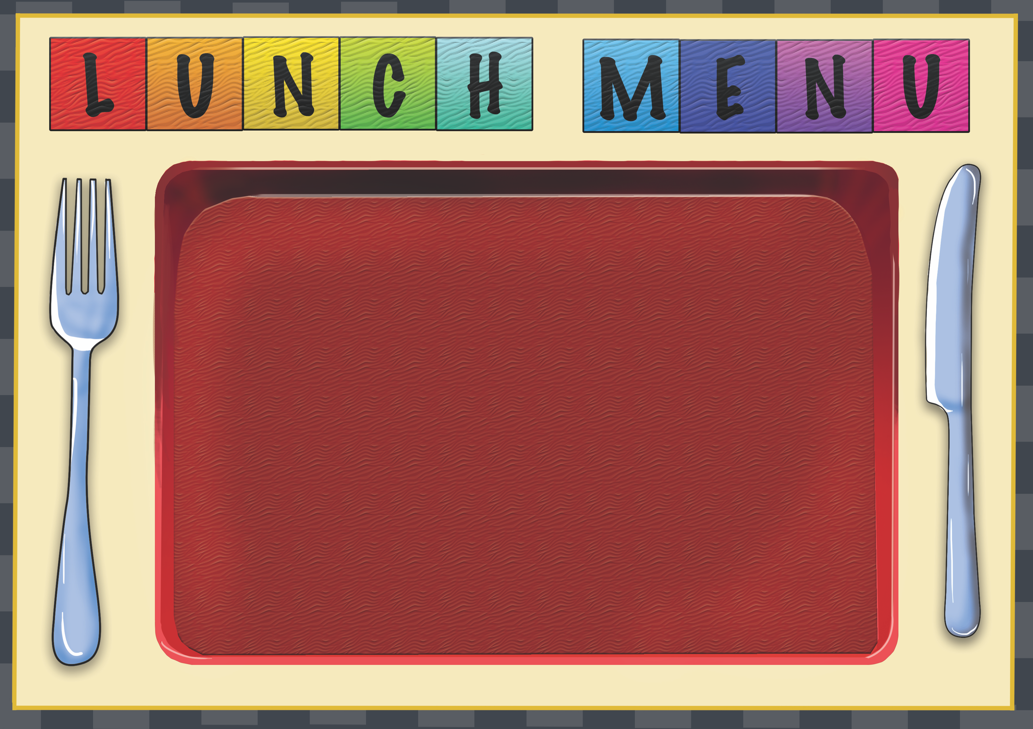
ssb
Week 1 | Dish of the Day | Dish of the Day 2 | Vegetables  Or Salad | Potato  or Rice | Dessert
Monday | Pasta Bolognese  1,2,3,6,7 | Vegetable Spring roll with Noodles  1,2,7,9,10,13 |  | Garlic Bread  2,6 | Homemade Biscuit or Cake or Fruit
Tuesday | Cheese & Tomato Flatbread  2,4,7 | Quorn & Vegetable Biriyani  1,2,13,14 |  | Potato Wedges | Homemade Biscuit or Cake  Or fruit
Wednesday | Fish Finger  2,4,5,7 | Quorn Cottage Pie  1,2,7,13 | Salad  Mixed veg | Chips | Homemade Biscuit or Cake  Or fruit
Thursday | Macaroni Cheese  2,7 | Cheese & Tomato Panini  2,4,7 | Salad | Garlic Bread  2,6 | Homemade Biscuit or Cake  Or fruit
Friday | Jacket Potato with a choice of fillings  4,5,7 | Beef Chili with rice  1,2 | Sweetcorn | Rice | Homemade Biscuit or Cake

