Home readers (matched to Phonics Phase/Book Band)
Reading for Enjoyment
Who | EYFS, Y1 and Y2- Y4 as per need | EYFS, Y1 and Y2- Y5 as per need | Y1 and Y2 -5 as per need | Y2 – Y6 | Y2 – Y6 | Y1 Daily using Bug Club and group model.  Y2-Y6 Daily using whole class RAMP model
What | Discrete teaching of Phonics  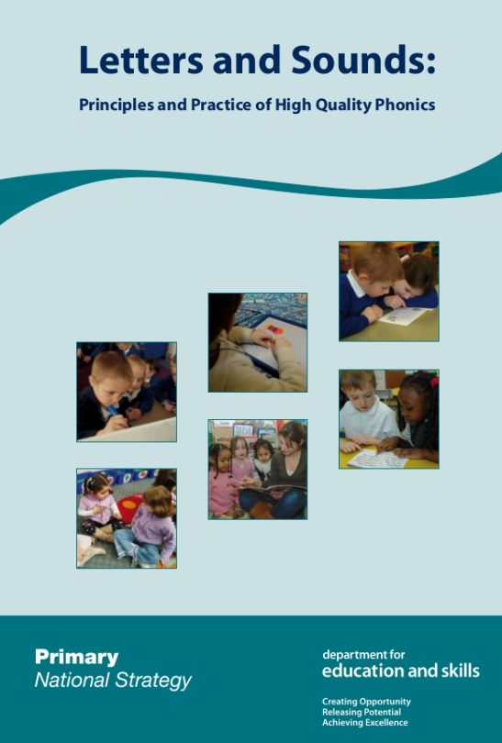  Letters and Sounds using RWI mnemonics | Fast Phonics  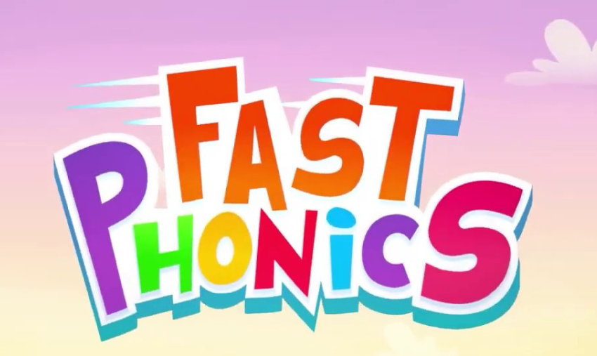  Pupils build on their Phonics skills until they reach Peak 14 (phase 4), they then take a placement test on Reading Eggs. | Reading Eggs  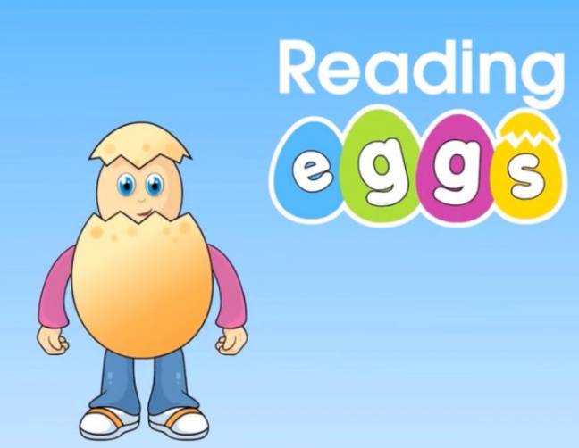  Once the teacher feels a pupil has made enough progress on Reading Eggs, they will take a STAR Reader assessment to move to AR. | Accelerated Reader  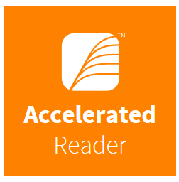  STAR Reading assessment will provide the ZPD range for each pupil.  Pupils are then able to choose books within their range take an online quiz to assess their understanding of the text read. | MyOn  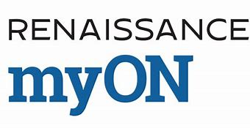  Synced with AR to provide access to a wider range of texts. | Guided Reading  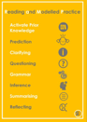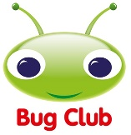  Used for home readers and Guided Reading.
When | Daily x 30 min sessions per week | 3 x 30 min sessions per week  Access at home | 3 x 30 min sessions per week  Access at home | 3 x 30 min sessions per week  Access at home | 3 x 30 min sessions per week  Access at home | Daily x 30 min sessions per week  Bug Club: Access at home
Discrete Phonics teaching
At Essa Primary Academy, we follow the Letters and Sounds (DfE 2007) scheme of work. We ensure that the teaching and learning of phonics best supports our children by providing opportunities for physical phonics, repetition and consolidation.

We believe that phonics teaching and learning should be:
•Systematic
•Discrete
•Interactive
•Physical
•Engaging
Pupils are provided with a variety of opportunities to develop and extend their phonics skills in and across Reception and KS1. This is also continued into KS2, where necessary to support those pupils who do not yet have the phonic knowledge and skills they need. Phonics lessons are taught by both teachers and teaching assistants daily for 30 mins.

Fast Phonics
Fast Phonics is hosted by Reading Eggs and is designed for emergent and early Reception and Year 1 readers and older primary pupils with gaps in their core reading knowledge. At Essa Primary Academy, we use Fast Phonics as a stepping stone to Readings Eggs. Pupils will use Fast Phonics to learn, practice and gain fluency in phonics before transferring this over to more in depth reading as part of Reading Eggs. Pupils build on their Phonics skills until they reach Peak 14 (phase 4), they then take a placement test on Reading Eggs.
Pupils are given 3 x 30-minute sessions every week for using Fast Phonics. They also have access at home.

Reading Eggs
Reading Eggs is a unique online platform where children learn to read. It supports each child’s learning by offering individual, one-on-one lessons that allow children to progress at their own rate. Prior to using Reading Eggs, pupils take a placement test which decides where they should begin their learning. The Reading Eggs programme focuses on a core reading curriculum of phonics and sight words using skills and strategies essential for sustained reading success. Teachers are able to access details reports about progress and lesson plans and resources to for interventions.
Pupils are given 3 x 30-minute sessions every week for using Reading Eggs. They also have access at home.

Accelerated Reader
We recognise the fundamental importance of reading as a foundation for all additional learning and use an online reading management programme called Accelerated Reader to improve children’s reading outcomes.

Each child is unique and Accelerated Reader allows us to foster and nurture this through the completion of STAR Reading assessment. This is a computer-adaptive test that gives rise to the pupil’s Zone of Proximal Development (ZPD), which is the ideal range of text complexity for that pupil. Pupils achieve the most significant gains in reading skills when they read books that are at the correct reading level for them.

Pupils are able to choose books within the range that interest them to read as their home/school reading book. Once the book has been read, pupils take an online quiz to assess their understanding of the text read. The teacher has access to comprehensive reports to monitor progress and determine appropriate intervention.

Pupils are given 3 x 30-minute sessions every week for reading and quizzing on AR.

MyOn
We understand how important it is for our pupils to have access to a wide number and range of book at all times both at home and in school. Therefore, we have introduced myON to be used alongside Accelerated Reader.

MyON is a personalised reading program that provides access to a large integrated collection of digital books. Created to enhance the reading experience, myON develops an individual profile for each pupil based on his or her interests and reading ability and generates a recommended book list.

MyON enables anytime, anywhere access to digital books that pupils can read, rate, review, and share with classmates through safe social networking. Through embedded assessments – end of book quizzes and benchmark quizzes – myON allows teachers to monitor, track and measure reading growth. MyON syncs with the Star Reader Quiz taken on Accelerated Reader to ensure that the books offered are within each pupil’s Zone of Proximal Development (ZPD range).
Pupils are given 3 x 30-minute sessions every week for reading and quizzing on myON. They also have access at home.
Bug Club
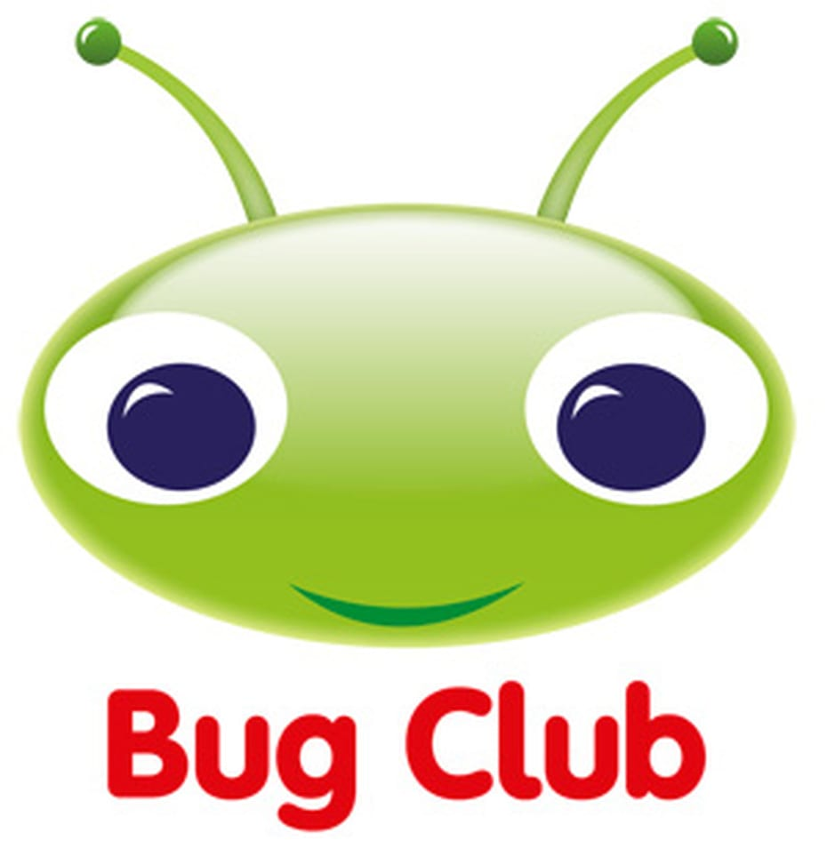

In order to complement our home reading offer for EYFS and Year 1, our pupils have access to an online reading resource called Bug Club. Bug Club is an online, finely-levelled reading scheme, which ensures that all children can find books at exactly the right level for them.

Using the online reading platform, each child has a unique homepage and log in details which can be accessed from and any device at any time. Class teachers allocate books for each pupil that match their phonics instruction phase and reading band.

Our school code is: wscl

In year 1, we also use Bug Club for Guided Reading. Pupils are organised by their phonics phase and have a 25-minute targeted reading session with their teacher focusing on the following:

Before reading: | Whilst reading: | After reading: | One to one reading
Looking at the book cover and talking about the pupils’ expectations. Asking question such as is the book likely to be fiction or non-fiction – how do we know? Have you read other books together about these characters or by this author? What do you think the book is going to be about? | Supporting the pupils when unknown words need tackling: you can sound them out, split them into syllables, or identify suffixes and prefixes. Reminding pupils to listen to the words whilst reading them, to make sure that they make sense. Have a ‘meaning check’ every now and again to ensure that they understand the text. | Talk about the book. What was it about? Did it match their expectations? Ask questions beginning with the words how and why to check that your child has been able to read between the lines. Ask whether anything seemed puzzling. Ask them to explain what the best and worst bits of the book were, and why. | : listening to each pupil read independently to assess and provided targeted support.

Guided Reading takes place in Year 1, daily for 25 minutes. Pupils have the opportunity to work with their teacher, read their home reading book and practice Phonics. Following on from their Guided Reading session, each pupil is provided with access to the book used for guided reading, a physical book which matches their phonics ability and access to other book within their phonics instruction phase.

Reading and Modelled Practice (RAMP
From Y2 we teach Guided Reading using the Reading and Modelled Practice (RAMP) approach created by the Arch Alliance English Hub. Through this model comprehension skills are explicitly taught, and the teacher empower learners to enable them to further develop their own comprehension.
Guided Reading is taught daily for 30 minutes through a whole class model with additional provision provided for pupils of SEND and/or very early EAL learners.

Readers develop and practice necessary skills critical to inference and deduction in focused sessions with the teacher and teaching assistants using the following cycle:

Activate Prior Knowledge | Prediction | Clarifying | Questioning | Grammar | Inference | Summarising | Reflection
This initial step encourages readers engage in activities to demonstrate an understanding of the text. This includes text to self where readers explain how the text relates to their experiences;  text to world during which readers make links between the text and the world, and finally text to text where readers make links between the text and other texts they have read. | This involves previewing the text to anticipate what may happen next. Readers can use the information from the text and their prior knowledge to make logical predictions before and during reading. Prediction can also be linked to the text type. | Pupils are supported to monitor their own understanding and identify any problems in comprehending sections of texts. Pupils should be encouraged to seek clarification from any aspect of the text they are reading.  e.g. clarify meaning, language structure, authorial intent etc. | Pupils are trained to ask themselves why questions whilst reading. They need to be taught the meaning of question words ‘who’, ‘when’, ‘why’. This will enable them to generate their own questions from a text using these question words. | When analysing the grammar of the text the pupils are taught how to determine the authorial intent in relation to using ‘coherence’- how the larger pieces of text work together and ‘cohesion’ – how sentences work together. | Pupils are shown how to make inferences as they read by using the strategies within the RAMP process e.g., ‘thinking aloud’, asking questions, pupils generating own questions etc. High level and open questioning promote the development of being able to infer meaning creatively from the text. Prediction is a form of inference enabling readers to check out the validity of the initial prediction.  Before the pupils make inferences from texts, they need to know how to make inferences from pictures (regardless of their age) | Summarising helps readers to construct an overall understanding of a text, story, chapter, or paragraph. Putting a summary into their own words requires information to be understood and transformed.  A good summary considers what has been read before and shows how the new | This final step enables the pupil to link their own understanding to the text, allowing them to establish ‘deeper learning and understanding’. This step in the cycle may be incorporated into the summarising section of the RAMP cycle. This is to establish that every pupil is provided with an opportunity to relate back to ‘text to self’, ‘text to text’ and ‘text to world.’

Phonics Interventions
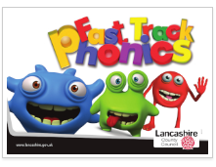
Fast Track Phonics: Targeted support for Y2 pupils who did not meet the expected standard in the Y1 Phonics Screening Check (PSC).

Fast Track Phonics has been developed to support children in Year 2 who did not achieve the expected level in the Year 1 PSC. It is designed to address gaps in learning. It is not intended to take the place of the daily phonics session and is delivered as an additional intervention sessions. It is not suitable for SEND or very new EAL learners.
Fast Track Phonics is a 14-week programme which focuses on the key skills of all good phonics programmes which are:
- Grapheme/phoneme correspondence.
- Blending to support reading.
- Segmenting to support spelling.
- Blending and segmenting as reversible processes.

Fast Track Phonics interventions take place 3 x a week in addition to daily teaching of Phonics.
Bounce Back Phonics: Catch up phonics lessons for Years 2, 3 and 4 based on the Letters and Sounds Programme.
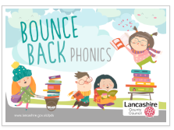
Bounce Back Phonics is a series of phonics lessons aimed at helping children in Years 2, 3 and 4 who may have missed, or not fully understood, some of the crucial stages of systematic synthetic phonics teaching in the early years. The intervention includes two blocks of work which address the teaching of Phases 4 and 5 tricky words. The lessons cover the alternative spellings of common vowel phonemes (Phase 5). There are six lessons which cover some tricky phonemes e.g. wr, ph, kn, gn, tch and softening c.
This intervention comes with a simple assessment tool helps to identify the phonemes that are needed to teach or to revisit, thereby filling crucial gaps in phonic knowledge.

This units of work support children who are experiencing difficulties with:
- blending phonemes for reading and segmenting for spelling.
- selecting the correct spelling for long vowel phonemes.
- reading and spelling longer words containing adjacent consonants.
Bounce Back Phonics interventions take daily during the teaching of Phonics/SPaG.

