**English**

**Text: ‘Zog’** by Julia Donaldson and **‘Pumpkin Soup’** by Helen Cooper

We will be recipe writing. Children will be innovating characters and settings in the story. We will be using capital letters in writing. We will also be looking at poems.

**Reading:** Please read daily at home with your child.  Whole class reading will be taught daily using RAMP activities and Little Wandle Phonics.

**Mathematics**

**This half term we will develop our understanding of:**

**Addition and subtraction (within 10)**

Number bonds to 10.

Solving addition problems.

Subtraction

Adding and subtracting 1 or 2.

Recognising, naming, and sorting 2D shapes.

Recognising, naming, and sorting 3D shapes.

Patterns within 2D and 3D shapes.

**Science**

The children will be learning to distinguish between an object and the material from which it is made. They will also identify and name a variety of everyday materials, including wood, plastic, glass, metal, water and rock.

**RE**

**What do we believe God is like?**

We will learn how to identify what a parable is and look at different parables to learn how caring and forgiving God is.

**Guided Reading**

Pupils need to read at home every night and bring in their folders daily.

Children will read in their groups with their class teachers and will practice key skills in decoding, prosody and comprehension using books matched to their phonic knowledge.

**Year 1**

**Autumn Term 2**

PE is on Thursday.

Please ensure pupils come into school in the school PE kit.

Reading books can be changed as needed.

Homework expectation: Daily reading/ Phonics home learning. (Reading diaries to be signed)

**Phonics**

The children will participate in daily phonics

**Music**

Rhythm In The Way We Walk and Banana Rap

Computing



We will use Purple Mash to create pictograms.

2PaintaPicture

**PSHE**

Celebrating Differences

(Curriculum map attached)

**PE**

**Invasion Games**​

We will be developing our understanding of ‘Invasion Games’ including attacking and defending skills.

**History**

**Toys**

Children will be looking at toys today and toys from the past. They will be comparing modern toys with Victorian toys and recognise how toys have changed overtime.

**DT**

Children will select from and use a wide range of materials and components, including construction materials, textiles, and ingredients, according to their characteristics

Use basic principles of a healthy and varied diet to prepare dishes

1. **Maths task:**

Choose a number between 1-10. How many different **number bonds** can you make for it?

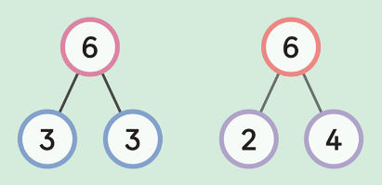

**4. Topic task:**

History

In History we are learning about Modern and Victorian toys. Write about your favourite toy. You can add a picture of it as well!

**3. English task:**

In English we have read ‘Pumpkin Soup’. Do you have any special recipes that you can make with adult at home? Write the recipe for it.

Don’t forget your capital letters and full stops!

**2. Creative task:**

Make your own musical instrument using recycled materials.

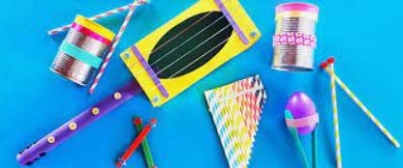

**5. Science**

Find objects around your house that are made of different material.

Can you take a photo or draw and label them?

**Homework:**

Please work through the boxes in order and complete each week.

Hand these in on a Wednesday for your teacher to celebrate your amazing work!

**Year 1**

**Autumn 2**

**Homework**

**Year 1**

This half term our class text is

Zog

**To help familiarize yourself with these words you can:**

* read the words and ask an adult to check that you have read them correctly.
* ask an adult or look up the meaning in a dictionary.
* try to say or write these words in a sentence.
* look for these words in other texts.

expert

sticky

roar

fly

plaster

peppermint

bonfires

bandage

career

stethoscope

dragon

M

