**Mathematics**

This half term we will develop our understanding of: time, shape and mass.

Children will learn how to tell the time and understand how to read different clocks. Children will learn the properties of different 2D and 3D shapes.

**Science**

This term we are learning about plants. Children will be able to identify all the different parts of plants and know what plants need to grow and survive.

**English**

Title: Fantasy Stories

Key Text: The Magic Faraway Tree.

Writing: Children to create their own fantasy story.

Spellings, Punctuation & Grammar (SPAG): Homophones, apostrophes for possession and contraction, adverbs, subordinating conjunctions, plurals and perfect form of verbs.

Reading: Character inference, intonation.

**RE**

Our RE unit this term is ‘How and why do we try to make the world a better place?’

Children will be looking at different religions and non-regions to see how everyone can work together to make the world a better place.

**Accelerated Reading**

* Pupils need to read at home every night and bring in their diary signed daily.
* They can then quiz in school
* These quizzes help to assess and improve your child’s reading age.

**Year 3**

**Summer 2**

PE is on a **Wednesday**

Please ensure pupils come into school in the school PE kit.

Reading books can be changed as needed and accelerated reading quizzes completed.

Homework expectation: Daily reading/ times tables and spellings. (Reading diaries to be signed)

**MFL**

Our topic this term is ‘Ca Pousse’ (Growing things).  
The children will be able to ask and answer questions, as well as expressing their own opinions.

**Music**

Our topic this half term is ‘bringing us together’ Children will be able to compose their own music and understand the history of different types of music.

Computing

Our unit this term is graphing. Children will use computer programming to make different graphs.



**PSHE**

Our topic this term is changing me.

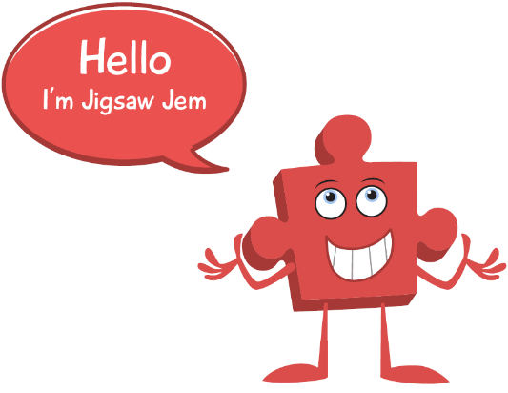

**PE**

This term Year 3 will be working with Primary Reds from Manchester United.

**Geography**

This term our Geography topic is Rainforests. Children will be able to locate different rainforests on a map and state what rainforests all have in common. Children will also be able to describe the different layers of rainforests and explain what can be found at each layer.

**Art**

Our topic this term is Materials. Children will use a range of different materials such as oil paints, clay, pencils, and charcoal to create their own artwork.

**3. English task:**

Write your own creative story. This can be about anything you want!

Try to be as imaginative as possible!

Think about:

What will happen?

What characters you want to include?

What scene descriptions can you give?

1. **Maths task:**

Draw different clocks to show what time of day you do things. For example:

What time do you get up?

What time do you have breakfast?

What time do you go to sleep?

**4. Topic task:**

Draw a poster to explain to people what they can do to help the rainforests from deforestation. Use what we have learnt in class to support this. You may also want to include some facts from your own research.

**2. Creative task:**

Have a look around your house. Think of all the different materials you can see/feel.

Draw some pictures of these objects and label them with what material you think they are. You can add colour to this!

**5. Topic task:**

Have a look at all the different flowers you can find. Write down where they are and what colours you can see. You can even draw some pictures of them.

**Homework:**

Please work through the boxes in order and complete each week.

Hand these in on a Friday for your teacher to celebrate your amazing work.

**Year 3**

**SUMMER 2**

**Homework**

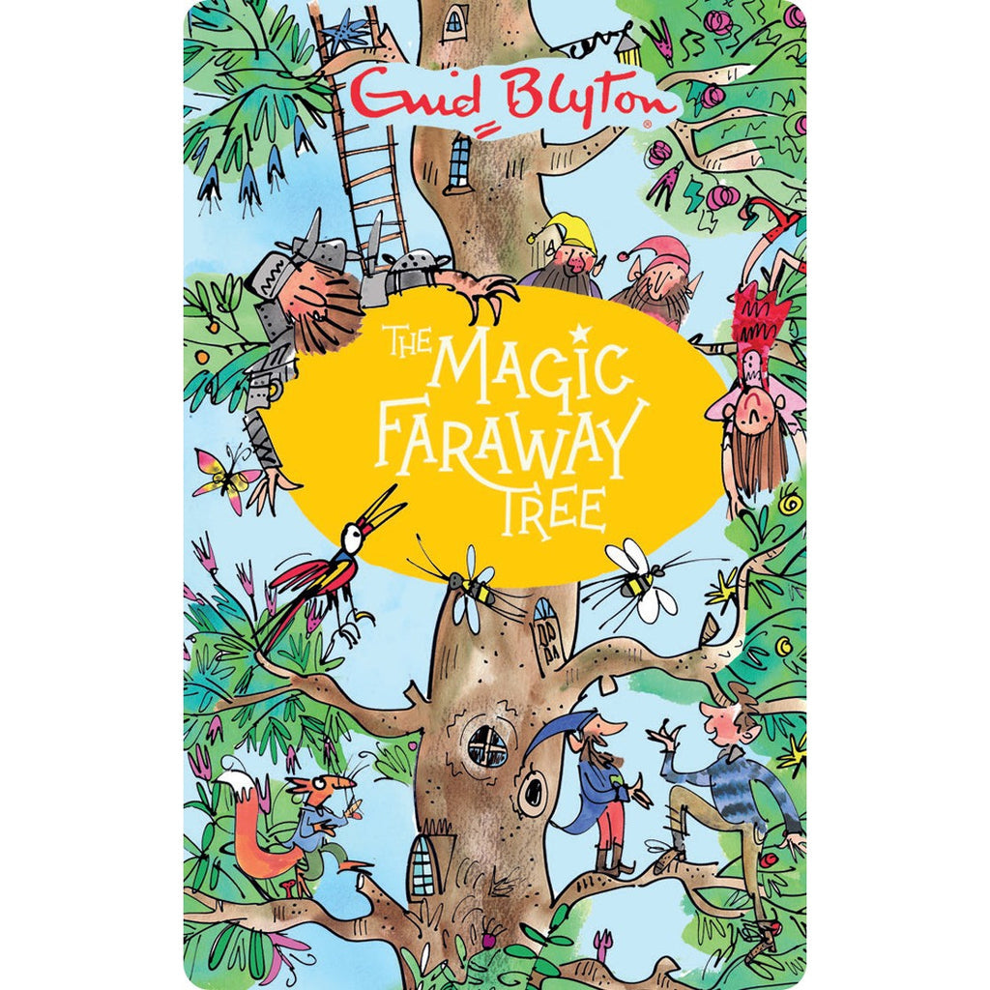

**Year 3**

This half term our class text is The Magical Faraway Tree by Enid Blyton.

**To help familiarise yourself with these words you can:**

* read the words and ask an adult to check that you have read them correctly.
* practise spelling these words correctly.
* ask an adult or look up the meaning in a dictionary.
* try to say or write these words in a sentence.
* look for these words in other texts.

moss

astonishment

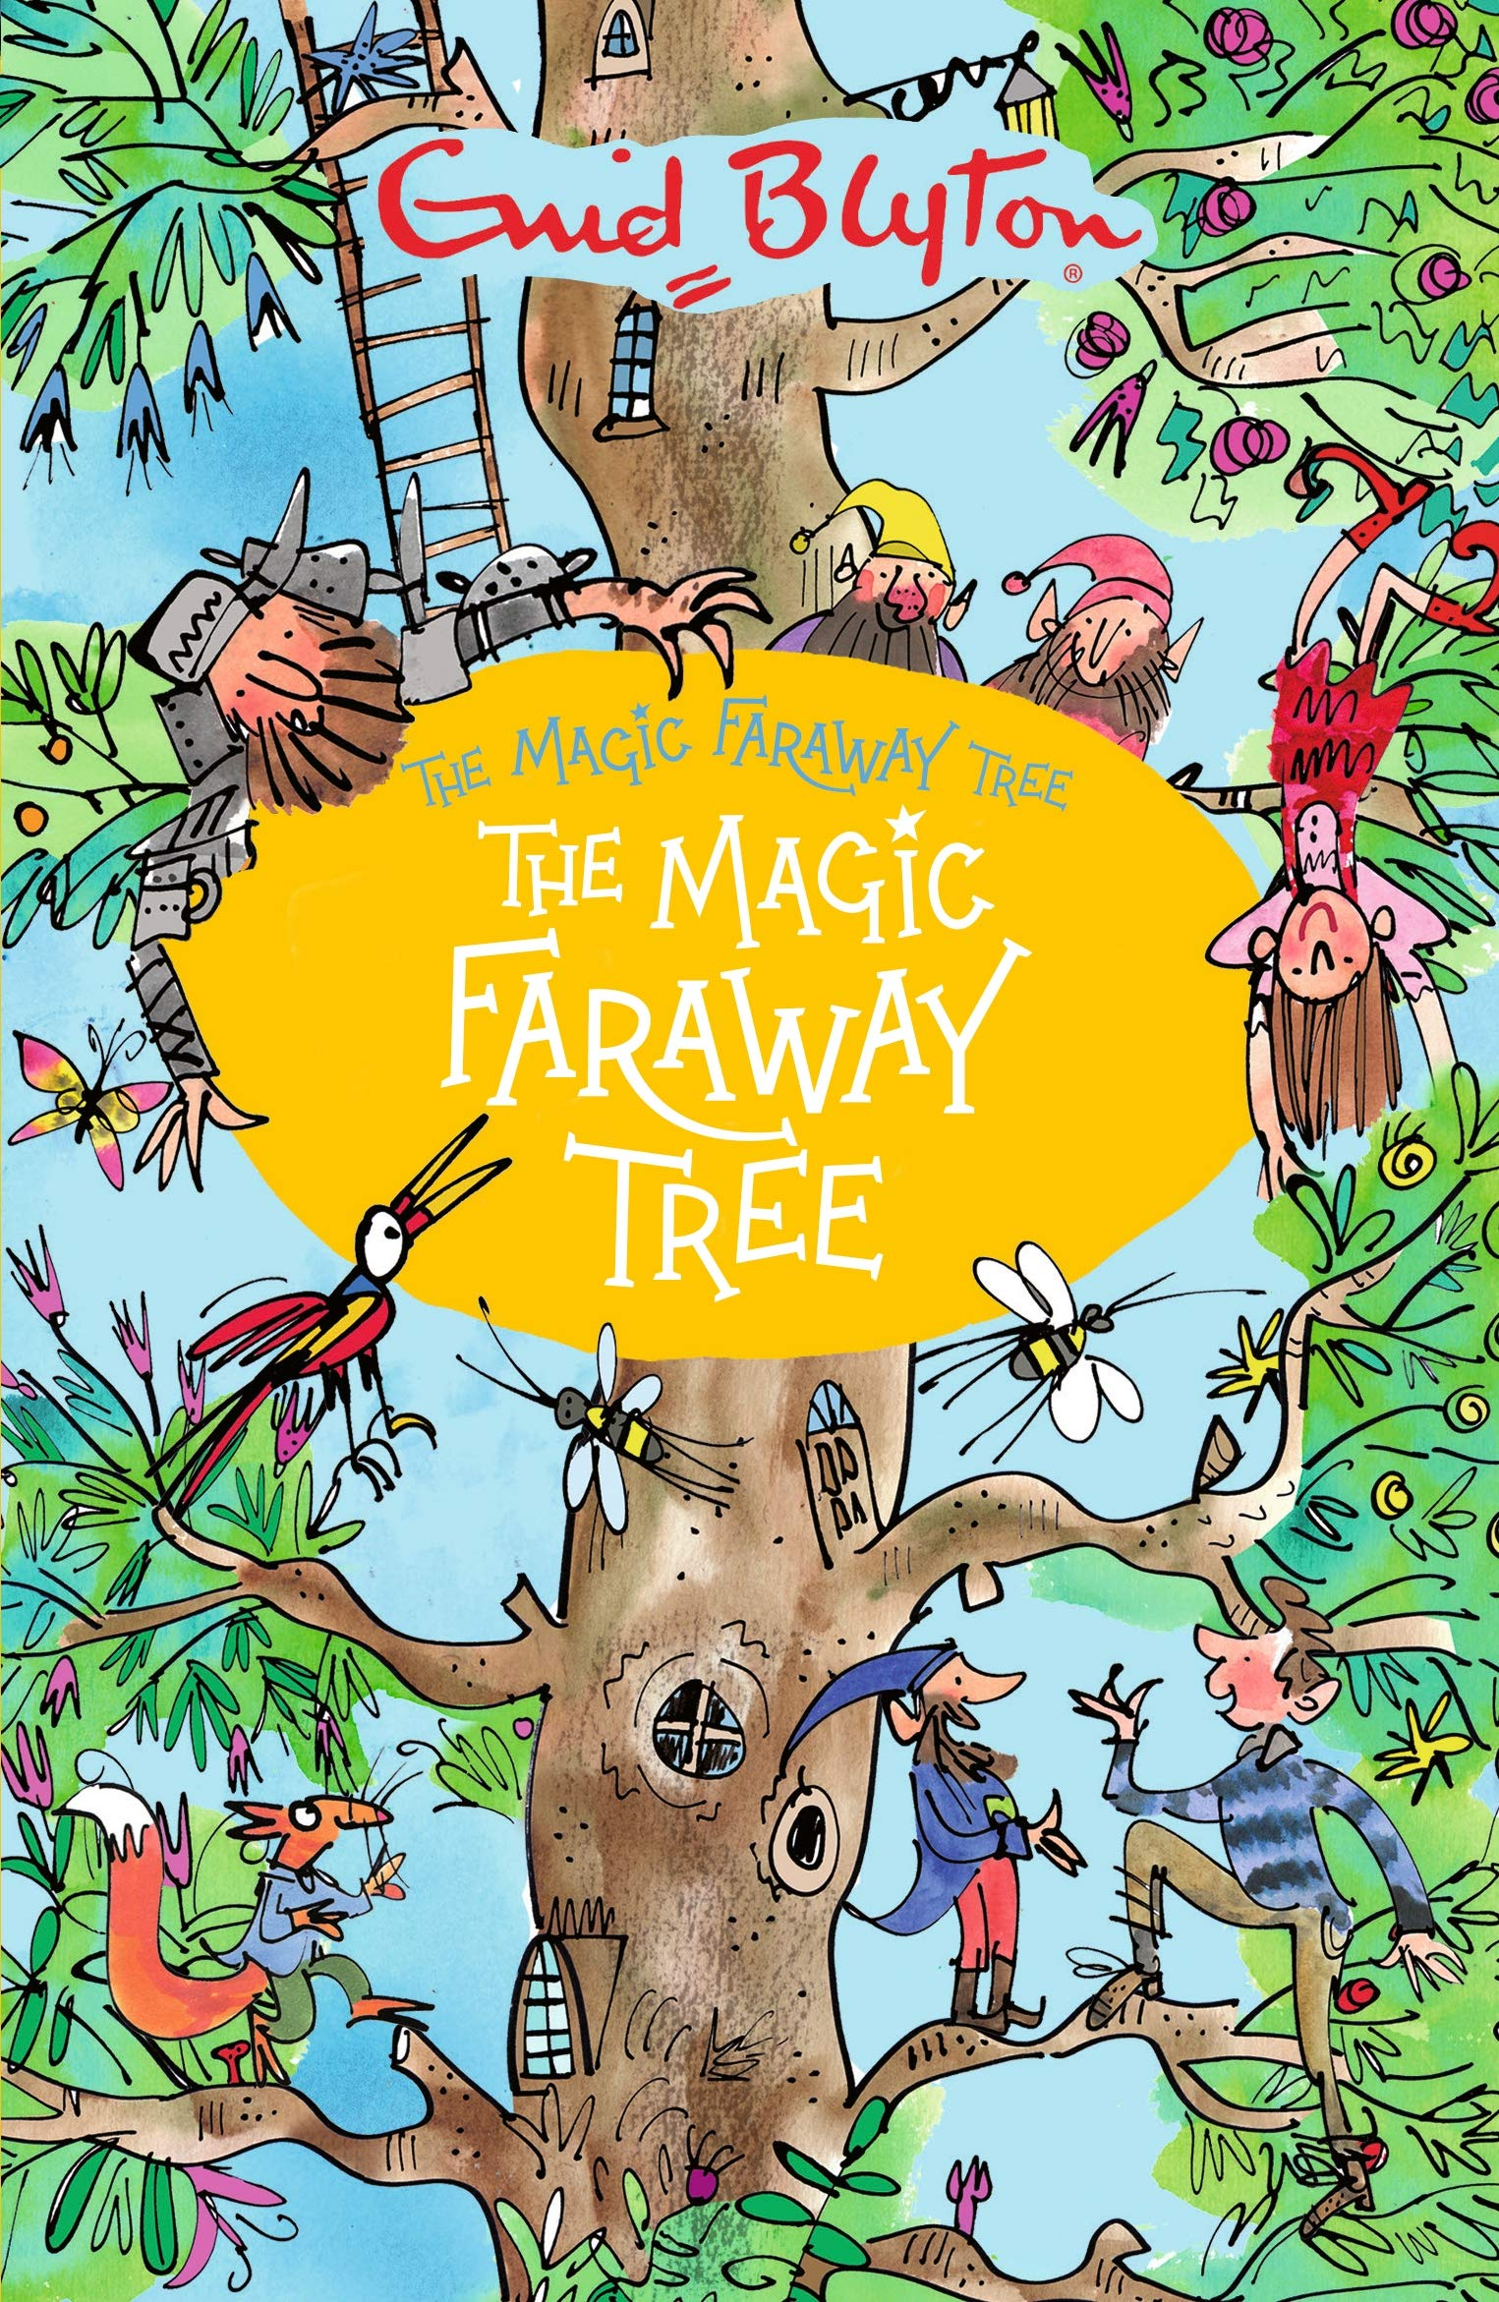

dismay

unlatched

peculiar

wept

bough

jerked

toadstools

dewy

enchanted